* Avoid non default constructor in fragment – Why?

Reason : - Default constructor of fragment class is invoked or used by fragment manager. So usage of non-default constructor would have no effect if the fragment is invoked by fragment manager. In other word a fragment would never get invoked if it is instantiated by non-default constructor.

[If anyone have any doubt – build an app with one activity and one fragment

1. Call that fragment using default constructor like this-“getSupportFragmentManager().beginTransaction().add(R.id.container , new YourFragment()).commit();”
2. Call that same fragment using non-default constructor like this-“getSupportFragmentManager().beginTransaction().add(R.id.container , new YourFragment(int m , int y , int x)).commit();”]

* How to detect overdrawing and avoid it?

Overdraw: - Overdraw refers to the event of rendering a pixel multiple times while rendering a single frame. Overdraw may cause bad app performance, if in any case, any single frame takes more or equal 16 milliseconds to be drawn on the screen.

Udacity Course on Android App Performance: -

<https://www.udacity.com/course/android-performance--ud825>

Overview On Figuring out of “Overdraw” in Android App: -

<https://io2015codelabs.appspot.com/codelabs/android-performance-debug-gpu-overdraw#1>

Above Two Link explains and covers detecting and avoiding overdraw in detail.

* Cycle.js: - Cycle.js denotes a java script framework where an application is considered like a function which takes event stream as input and gives another event stream as output.

Continuous Integration(CI): - CI is a development process/practice where a developer integrates codes into a shared repository several times a day. Each check-in is then verified by automated build which allows team to encounter problem very early.

* Staged Rollout: - It’s a procedure by which app update is released to intended users.
* AsyncTask: - It is a generic class that is used to do the long running task in background and fetching updates from background. In more generic sense asynchronous task means any task whose execution will be performed separately from the main thread.

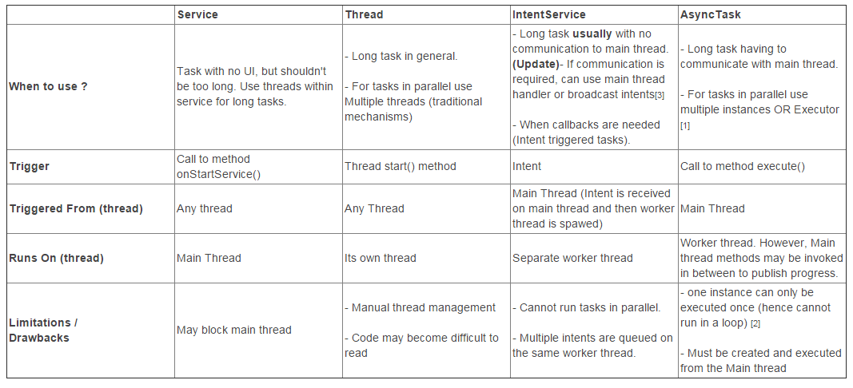

* RSS feed: - RSS stands for “Rich Site Summary” and is a format for delivering regularly changing web content(basically XML format).
* Dependency Injection : -----------------------------------------------------------------------------------------------------------------------------------------------------

<https://www.youtube.com/watch?v=GDkL2uEn8cg>

https://www.youtube.com/watch?v=IKD2-MAkXyQ